HIV Tests Performed since the last report | 1,529 | 107 positives
Total HIV Tests Performed during grant term | 3360 | 250
Total TB Tests to date | 2774 screened,1414 presumed | 93 diagnosed
TB Tests since last report | 1568 screened ,774 presumed | 53 diagnosed
Total STI tests to date | 1012 | 232 positives
STI Tests since last report | 876 | 314
Condoms distributed since last report | 385,251
Total condoms distributed during Grant term | 820,000
Linkage to care since last report | 160
Total linkage to care during grant period | 343
Outreach/Education since last report | 419
Total outreach/education during Grant term. | 636
Tel: +256 789084004
+256 781242684
+ 256-770736311
shineafricaministries@gmail.com/
safteso@gmail.com
https://safteso.netlify.app/
Plot1-7 Olio Avenue Old Mbale Road Red Cross
Building
P. O. Box 684, Soroti Uganda, E. Africa

SAF-Teso
Shine Africa Foundation -Teso
“Empowerment through sustainable community led interventions in the Teso Sub-Region.”

NUMBERS TO DATE ASSOCIATED WITH YOUR FUNDED PROGRAM
SUMMARY OF TARGETS:
S/N | Activity | Target | Achievement | % | Comments
01 | Disseminate HIV/TB messages | 50,000 | 71,000 | 142% | Achieved through demand creation, sensitization drives education out reaches and radio talk shows.
02 | Conduct HIV testing | 1,000 | 3,360 | 336% | This was achieved through targeted HIV testing and outreaches for the target groups. 3,360 tested, 250 positives identified.
03 | Condom distribution | 720,000 | 820,000 | 113.9% | condoms were distributed in hotspots, clinics ,bars, shops leisure centers to improve access to HIV prevention
04 | Referrals and linkage to care | 100% | 343 | 100% | 250 HIV positives and 93 TB identified positive were linked to care and started on treatment.
05 | Follow-up of clients to support retention | Not specified in the project proposal | 588 |  | All these clients were followed up through home visits and phone call reminders for drug refill
06 | Provision of intensive adherence counselling | Not specified in the project proposal | 269 |  | 269 clients who were non-suppressed were provided IAC to support them adhere to treatment
07 | TB contact tracing | Not specified in the project proposal | 2,774 |  | 2,774 contacts were followed and screened for TB ,1414 were presumed and tested for TB ,93 tested positive for TB
08 | Train peer leaders | 25 | 25 | 100% | Peer leaders were trained on the provision of HIV/TB prevention services at the beginning of project implementation.
09 | Formation and support of CCLADS | 09 | 10 | 111.1% | These groups were supported through provision of psychosocial support, community drug refill ,counseling, positive living ,HIV testing for discordant ,index clients testing
10 | Conducting radio talk shows | 6 | 6 | 100% | This was conducted in the radio station with high listenership in Teso sub-region
11 | STI screening and testing | Not specified in the project proposal | 1,012  232 positives identified |  | STI screening was conducted in all Out patient department in all supported health facilities.

Report on progress for stated measurable Objective 1: To increase Prevention of new HIV/TB infections.
SAF-TESO has scaled- up HIV testing and counseling services in the communities and target groups were supported during project implementation, targeted testing was recommended to individuals at higher risk to ensure early diagnosis and linkage to care. Expanded access to ART to not only improve the health outcomes of individuals living with HIV but also reduces their risk of transmitting the virus to others.
SAF-TESO during project implementation, promoted and greatly conducted TB screening for TB contacts, people living with HIV and hotpot communities and treatment for those tested positive for TB which is essential to identify and treat latent TB infections and prevent the development of active TB disease.
We also Promoted safer behaviors, such as encouraging consistent condom use, harm reduction strategies for people who inject drugs hence reducing the risk of HIV and TB transmission
A total of 3,363 individuals were mobilized and tested for HIV during the project implementation 664 during APN testing,255 during social network testing strategy,170during index client testing,1742 during conducting targeted outreaches for men and 452 were Presumed TB clients tested for HIV.
250 clients were tested positive for HIV and were linked to care ,116 identified during APN testing ,39 during social network strategy,11 during index client testing,64 during targeted outreaches for men and 20 were presumed TB clients who tested positive for HIV all these clients were linked to care in the supported health facilities.
A total 2,773 TB contacts were screened for TB 1414 were presumed to have TB and their sputum samples were collected for TB test ,93 tested positive for TB and were started on treatment.623 clients were started on TB prevention therapy
Since the last report, 1568 clients were screened for TB, 774 were presumed to have TB and were tested, 53 tested positive for TB and were started on TB treatment.350 clients were started on TB prevention therapy.
Report on progress for stated measurable Objective 2: To increase linkage and referrals to HIV and other services
SAF-TESO has played a big role in ensuring that individuals at risk of HIV or those already diagnosed with the HIV /TB receive appropriate and timely care services these include testing, counseling services, treatment and community support programs these have also significantly reduced the rate of loss to follow-up among people living with HIV. This means that more individuals are successfully connected to sustained treatment and support services improves adherence, viral suppression, and overall health outcomes it has also expanded access to a range of HIV services, including antiretroviral therapy (ART), mental health counseling, adherence support, prevention interventions, and social support networks. These comprehensive services address the holistic needs of individuals living with HIV/TB hence improving their overall well-being and quality of life. In order to ease contact tracing and follow up of among TB and HIV Positive clients, the organization, donated seven (07) buffalo bicycles to linkage facilitators to support them in follow up outreaches among lost clients.
All 344 identified HIV/TB clients were linked to care. During the project term, a total of 250 HIV positives and 94 TB positive clients were linked to HIV and TB care and all started on treatment in the supported health facilities.
SAF-TESO conducted 6 radio talk shows to increase demand for HIV and TB services. This was conducted by two technical panelists. 2 monthly sensitization drives were conducted in the project catchment key populations and priority populations
A total of 820,000 Condoms were distributed to hotspots, leisure centers, lodges, bars and clinics both female and male condoms in Soroti and Serere district. This activity was conducted by peer educators and condom marketers.
Report on progress for stated measurable Objective 3: To provide lifesaving care and treatment to people living with HIV/TB.
Early diagnosis is crucial for initiating appropriate treatment and preventing further transmission. SAF-TESO has Integrated HIV and TB testing services, along with increasing screening efforts to ensure prompt identification of co-infected individuals, enabling timely interventions.
For people living with HIV/TB, we have supported in their retention to care and linkage to treatment to strengthens the immune system, reducing the risk of TB progression and improving treatment outcomes. Also Implementing directly observed therapy (DOT) for TB treatment to support ensure adherence, minimize drug resistance, and enhance treatment success rates.
With the support from the supported health facilities we have been able to initiate clients to TB preventive therapy, such as isoniazid preventive therapy (IPT) for people living with HIV hence significantly reducing the risk of developing active TB. This intervention has played a critical role in preventing TB infection and reducing morbidity and mortality among our clients.
Intensive adherence counseling was also provided to educate patients about the importance of treatment adherence, identify and address barriers to adherence, provide ongoing support, and empower individuals to actively participate in their own healthcare.
Throughout the project implementation,588 clients who missed appointment were followed through home visit and phone call reminders. all these clients were brought back to care in the supported health facilities. since the last report, 214 clients who missed appointment were followed-up and brought back to care159 to Serere health center IV,31 to Kichinjaji HC III and 24 to Asuret Health Center III.
A total of 269 clients with non-suppressed viral loads were followed and provided intensive adherence counseling during the project period.
Since the last report,91 clients with non-suppressed viral loads were provided intensive adherence counselling .14 from Kichinjaji health center III and 77 from Serere HC IV

HIV TESTS PERFORMED SINCE THE LAST REPORT
since the last report, a total of 1,529 individuals were tested for HIV, with the following breakdown:
- APN Testing:
  - Number of individuals tested: 175
  - Number of HIV positives identified and linked to care: 36
- Social Network Strategy Testing:
  - Number of individuals tested: 159
  - Number of HIV positives identified and linked to care: 26
- Index Client Testing:
  - Number of individuals tested: 35
  - Number of HIV positives identified and linked to care: 2
- Outreach for Men Testing:
  - Number of individuals tested: 972
  - Number of HIV positives identified and linked to care: 35
- Presumed TB Clients Testing for HIV:
  - Number of individuals tested for HIV: 169
  - Number of HIV positives identified and linked to care: 8

TOTAL HIV TESTS PERFORMED DURING GRANT TERM
SAF-Teso conducted Targeted HIV testing which has played a crucial role in the prevention, early diagnosis, and management of HIV/AIDS and TB. By identifying individuals who are more likely to be infected, this program has effectively reach those who are unaware of their HIV status. Hence reducing transmission rates, ensure timely access to treatment, and provide essential support services.
During the project term, a total of 3,360 individuals were mobilized and tested for HIV 664 through APN testing, 295 through SNS testing, 170 through index client testing 1,742 during outreach for men and 452 were TB presumptive clients tested for HIV.
250 HIV positives were identified and linked to care and treatment 116 through APN testing, 39 through Social network strategy testing, 11 through index client testing, 64 through outreach for men and 20 were presumed TB clients who tested positive for HIV.

TOTAL TB TESTS TO DATE
A total of 2,773 TB contacts were screened for TB, 1,414 were presumed to have TB and their sputum samples were collected from community and taken to facility for TB test, 93 tested positive for TB and were started on TB treatment, 623 TB contacts were initiated on TB prevention therapy.
TB TESTS SINCE LAST REPORT
A total of 1,568 clients were screened for TB 774 were presumed to have TB signs and were tested for TB ,53 tested positive for TB and were started on TB treatment.350 were initiated to IPT.
TOTAL STI TESTS TO DATE
A total of 1,012 clients were tested for STIs a total of 232 were tested positive for STIs and started on treatment. STI screening helps individuals understand their sexual health status and detect any infections they may have contracted. It allows for timely treatment, which can prevent the progression of the infection and reduce the risk of transmission to sexual partners. we also recommended that sexually active individuals, particularly those who have multiple partners or engage in high-risk sexual behaviors, undergo regular STI screening. Additionally, individuals with symptoms suggestive of an STI or those who have had sexual contact with an infected partner should seek testing. STIs screened for include: Gonorrhea, Syphilis, Hepatitis B and C and Urinal track infections.

STI TESTS SINCE LAST REPORT
A total 876 individuals were tested for STI during OPD clinics at health facility 314 tested positive for STI and were started on treatment
CONDOMS DISTRIBUTED SINCE LAST REPORT
The primary goals of condom distribution programs are to promote safe sexual practices, reduce the incidence of STIs, and prevent unintended pregnancies. By providing easy access to condoms, these programs aim to remove barriers such as cost, social stigma, and limited availability. They also typically include educational components to raise awareness about condom use, proper techniques, and the importance of consistent and correct usage.
A total of 385,251 pieces of condoms were distributed since last report. These were distributed by condom marketers and peer educators to increase access to HIV prevention services.
TOTAL CONDOMS DISTRIBUTED DURING GRANT TERM
A total of 820,000 pieces of condoms were distributed during grant term this activity was conducted by condom marketers and peer educators to increase access to HIV prevention services.

LINKAGE TO CARE SINCE LAST REPORT
A total of 160 were linked to care and treatment 107 were clients who tested HIV positive were linked to care and treatment and 53 clients who tested positive for TB disease were linked and started on treatment.
Approximately 19000 individuals were reached with HIV/TB prevention messages since last report this was done through door to door sensitization, sensitization drives, education sessions
Total linkage to care during grant term
A total of 343 clients were linked to care and treatment, 250 were clients who tested positive for HIV and 93 were clients who tested positive for TB. these clients were identified in the communities and linked to health facilities for care and treatment.
Approximately 69,000 high risk individuals from Serere and Soroti district were reached with HIV and TB messages through radio talk shows, door to door sensitization, health education and counseling.
Outreach/education since last report
Sensitization outreach programs for HIV and TB prevention implemented by SAF-TESO have played a crucial role in raising awareness, providing education, and promoting behavior change to prevent the transmission of these diseases. These initiatives aim to reach diverse populations, including high-risk groups, vulnerable communities, and the general public. Here are some strategies commonly used in sensitization outreach efforts for HIV and TB prevention
A total of 419 education outreaches were conducted since last report this was done through door to door sensitization, sensitization drives and radio talk shows.
Total outreach/education during grant term
A total of 636 education outreaches were conducted during grant term hence reaching out to diverse populations, including high-risk groups, vulnerable communities, and the general public. Here are some strategies commonly used in sensitization outreach efforts for HIV and TB prevention
DESCRIBE ACTIVITIES COMPLETED SINCE RECEIPT OF GRANT AWARD
- Trained 25 peer leaders on HIV/TB this was conducted at the beginning of the project to refresh and increase knowledge of peers in HIV and TB activities
- Conducted 55 targeted Peer to peer sensitization sessions on HIV/TB this was done through door-to-door sensitization in the catchment areas with people at high risk of acquiring HIV and TB infections. for example, the landing sites, hotspots, and slum areas.
- Condom promotion, education and distribution to increase access to HIV prevention especially for the key population, priority population in 52 hotspots of soroti and Serere district.
- Conducted demand creation for HIV and TB services in order to increase demand for HIV/TB services. This was done by conducting 3 bi-monthly radio talk shows, 4 sensitization drives and door to door sensitization done by the Village health teams
- Conducted targeted high positivity HIV testing strategies of index testing, assisted partner notification, social network strategy and outreaches for men to increase on the number of people getting to know their HIV status and increase linkage to care
- Conducted TB contact tracing, follow-up of presumptive and confirmed TB cases and TB drug delivery for clients who miss appointment.
- Developed referral directory for contacts of service providers and referral points for TB/HIV services
- Conducted community facility escorted referral for identified TB and HIV clients who have not been linked to care
- Followed-up clients with missed appointments and brought back 93 to care using the approaches of home visits and phone call reminders
- Supported the formation of 9 Community client led ART Delivery groups and family support groups and provided integrated HIV/TB services e.g. referrals, couple counseling, supported disclosure, drug refill and GBV, STI screening.
- Provided intensive adherence counseling to 80 clients with non- suppressed viral loads.>1000 copies.

DESCRIBE PROGRAM TARGETS MET SINCE GRANT AWARD
Increase number of people who know their status by providing targeted HIV and TB services to 333 clients.
A total of 3,363 individuals were mobilized and tested for HIV during the project implementation 664 during APN testing,255 during social network testing strategy,170during index client testing,1742 during conducting targeted outreaches for men and 452 were Presumed TB clients tested for HIV.
250 clients were tested positive for HIV and were linked to care .116 identified during APN testing ,39 during social network strategy,11 during index client testing,64 during targeted outreaches for men and 20 were presumed TB clients who tested positive for HIV all these clients were linked to care in the supported health facilities.
A total 2,773 TB contacts were screened for TB 1414 were presumed to have TB and their sputum samples were collected for TB test ,93 tested positive for TB and were started on treatment.623 clients were started on TB prevention therapy
To increase access to 100% linkage and referrals to HIV and TB services
All 343 identified HIV/TB clients were linked to care. During the project term, a total of 250 HIV positives and 93 TB positive clients were linked to HIV and TB care and all started on treatment in the supported health facilities.
SAF-TESO conducted 6 radio talk shows to increase demand for HIV and TB services. This was conducted by two technical panelists. 2 monthly sensitization drives were conducted in the project catchment key populations and priority populations
A total of 820,000 Condoms were distributed to hotspots, leisure centers, lodges, bars and clinics both female and male condoms in Soroti and Serere district. This activity was conducted by peer educators and condom marketers.
To increase rates of 95% retention and adherence to treatment among people living with HIV.
The project implemented strategies to increase retention and adherence to treatment among people living with HIV. Here is a revised version of the information for clarity:
"To achieve a 95% retention and adherence rate among people living with HIV, the project implemented various interventions. Throughout the project implementation, a total of 588 clients who missed their appointments were proactively followed up through home visits and phone call reminders. As a result, all of these clients were successfully brought back to care in the supported health facilities. Specifically, 405 clients were re-engaged with Serere HCIV, 92 clients with Kichinjaji HC III, 61 clients with Asuret HC III, and 30 clients with Tubur HC III.
Additionally, the project focused on addressing non-suppressed viral loads among clients. A total of 269 clients with non-suppressed viral loads were closely monitored and provided with intensive adherence counseling during the project period. These efforts aimed to support clients in achieving viral suppression and improving their overall health outcomes."
By revising the information, it provides a clear and concise summary of the actions taken to ensure retention and adherence to treatment among people living with HIV, as well as the outcomes achieved through home visits, reminders, and intensive counseling for clients with non-suppressed viral loads.
Describe key achievements and challenges to program implementation during grant period
Program achievements
The program achievements you have listed are indeed significant and demonstrate the positive impact of the HIV/TB prevention programs. However, I can help you enhance the descriptions to make them more impactful and concise. Here are the revised versions:
- Successful Project Initiation: The program was launched with a well-executed project plan, clearly defined goals, objectives, and realistic timelines. This ensured a strong foundation for the program's implementation and set the stage for future success.
- Stakeholder Engagement: The program excelled in engaging key stakeholders, including community members, local organizations, and government agencies. Their active involvement and collaboration played a pivotal role in aligning the program with the needs and priorities of the target population, fostering a sense of ownership, and maximizing the program's impact.
- Increased Access to Testing and Treatment: The HIV/TB prevention programs achieved significant progress in expanding access to essential testing and treatment services. Through the implementation of innovative community-based testing initiatives, a larger number of individuals were successfully reached, diagnosed, and linked to appropriate care, thereby reducing barriers to early detection and treatment.
- Improved Awareness and Education: The HIV/TB prevention programs made remarkable strides in raising awareness and educating communities about the modes of transmission and effective prevention strategies. These efforts resulted in increased knowledge about HIV/TB, a reduction in stigma surrounding the diseases, and an improved adoption of preventive measures within the communities served.
- Integrated Service Delivery: An important accomplishment of the program was the successful integration of HIV and TB services within healthcare settings. By combining these services, individuals co-infected with both diseases received comprehensive care that resulted in improved treatment outcomes and significantly reduced mortality rates.

- Donated seven buffalo bicycles to 7 linkage facilitators to improve contact tracing and follow up
These revised descriptions highlight the significant achievements of the HIV/TB prevention programs while maintaining clarity and conciseness.
Challenges
- Health System Weaknesses: In some settings, weak health systems have posed a challenges to the effective implementation of HIV/TB prevention programs. For example shortage of healthcare workers and limited laboratory capacities has impeded timely diagnosis, treatment initiation, and monitoring of patients.
- Rising fuel cost that limited frequent movement to the field hence limiting the reach to far distance communities with a high burden of HIV/TB incidences.
- Access to Marginalized Populations: Reaching marginalized populations, such as people who inject drugs, sex workers, and transgender individuals, remains a challenge due to various factors, including social marginalization, criminalization, and limited access to healthcare. Tailored strategies and community-led approaches are required to engage these populations effectively.
- SAF-TESO supported a few health facilities hence there is need to scale-up HIV/TB program to more health centers located in catchment area with high burden of HIV/TB incidences in the Teso sub-region.
Describe future plans for program or project after grant award
After the grant award, SAF-TESO has identified additional strategies and initiatives to enhance their HIV/TB prevention programs. These plans aim to address specific needs and challenges while promoting sustainable change and community empowerment. The revised report includes the following enhanced future plans:
- Strengthening Partnerships and Collaboration: SAF-TESO recognizes the importance of partnerships and collaboration in achieving their goals. They will actively seek collaborations with local and international organizations, government agencies, and community-based groups. These partnerships will facilitate knowledge sharing, resource mobilization, and joint advocacy efforts to strengthen the overall response to HIV and TB.
- Enhanced Community Mobilization: SAF-TESO acknowledges the significance of community mobilization in driving behavior change and awareness. To facilitate this, the organization will provide PLHIV Networks with bicycles for mobilization, drug deliveries, awareness-raising activities, and meetings. This support will empower PLHIV Networks to reach remote communities, provide essential services, and raise awareness about HIV and TB prevention.
- Capacity Building and Income Generation: SAF-TESO is committed to building the capacity of PLHIV Networks to ensure their sustained engagement and empowerment. In addition to training PLHIV Networks on essential skills like soap making, SAF-TESO will explore other income-generating activities that align with the skills and resources of the communities. This will enable PLHIV Networks to generate income, improve their livelihoods, and contribute to the sustainability of HIV/TB prevention efforts.
- Innovation in Project Strategies: SAF-TESO aims to continually improve their HIV and TB prevention strategies through innovation. The organization will invest in research and development to identify new approaches, tools, and technologies that can enhance program effectiveness. They will actively explore innovative ideas, pilot projects, and evidence-based interventions to address emerging challenges and improve outcomes.
- Advocacy and Policy Influence: SAF-TESO recognizes the importance of advocating for policies that support HIV and TB prevention efforts. They will actively engage in advocacy campaigns at the local, national, and international levels to promote policies and funding mechanisms that prioritize prevention, testing, treatment, and support services. SAF-TESO will work closely with key stakeholders, including government bodies, policymakers, and civil society organizations, to influence policies and ensure a favorable environment for program implementation.
- Monitoring, Evaluation, and Learning: To measure the impact of their programs and make informed decisions, SAF-TESO will strengthen their monitoring, evaluation, and learning systems. They will develop robust data collection tools, conduct regular assessments, and utilize feedback mechanisms to monitor program performance, identify areas for improvement, and ensure accountability. The organization will embrace a culture of learning, actively sharing best practices and lessons learned to inform future program design and implementation.
- Gender-Responsive Approaches: SAF-TESO recognizes the importance of gender-responsive programming in addressing the specific needs and vulnerabilities of women, girls, and gender diverse individuals. Future plans include integrating gender-responsive approaches into their HIV and TB prevention programs, ensuring equitable access to services, addressing gender-based violence, and promoting gender equality and women's empowerment.
- SAF-Teso also plans to support a majority of the community structures with buffalo bicycles that will ease their movements to the field during drug delivery, drug refills, and follow-up through home visits to support retention and adherence to treatment, strengthen referrals, linkage to treatment and improve access to health services.
By incorporating these additional future plans, SAF-TESO aims to create a realistic and comprehensive strategy to address the complex challenges of HIV and TB prevention effectively. These plans emphasize community engagement, innovation, capacity building, advocacy, and learning to ensure sustainable impact and improve the overall well-being of affected populations.

Future Plans for SAF-TESO's HIV/TB prevention programs, incorporating statistical data and tables:
- Strengthening Healthcare Systems:
Objective: Improve the delivery of HIV/TB prevention services by addressing healthcare system weaknesses.
Future Plans | Target
Provide Continuous quality improvement to ensure that HIV/TB prevention services are delivered consistently and adhere to established standards. | 90% improvement in service delivery.
Promote integration of HIV/TB prevention services with other healthcare services to increase accessibility and effectiveness | 95% increased access to HIV/TB services
Provide comprehensive training and capacity-building programs for healthcare professionals, particularly in areas such as HIV and TB prevention, diagnosis, and treatment. | 95% improved staff capacity.
- Scaling up Testing and Treatment:
Objective: Expand access to HIV and TB testing and improve treatment outcomes.
Future Plans | Target
Integrating HIV and TB testing services with other healthcare facilities and organization programs | 85% activity integration.
Implement targeted HIV testing | Increase testing uptake for most at risk of acquiring HIV by 20%.
Promote the use of self-testing kits | Provide self-testing kits to 30% of the target population
Ensure test and treat | Initiate treatment within 72 hours for 100% of diagnosed individuals
- Integrated and Holistic Service Delivery:
Objective: Provide comprehensive care through the integration of HIV and TB services.
Future Plans | Target
Establish integrated service delivery for HIV/TB | 100% of healthcare facilities provide integrated services
Strengthen referral systems | Ensure 95% of individuals are referred to appropriate care
Improve treatment outcomes | Achieve 95% viral suppression among individuals in care
- Targeted Approaches for Key Populations:
Objective: Address the specific needs of marginalized populations.
Future Plans | Target
Develop tailored interventions | Increase access to prevention and treatment by 25%
Collaborate with community-based organizations | Engage 80% of targeted populations in program activities
Reduce stigma and barriers | Achieve 50% reduction in discrimination and stigma
Increase on the utilization of HIV prevention services by key populations | Achieve 95% utilization of HIV prevention services
- Community Engagement and Empowerment:
Objective: Foster community involvement and ownership.
Future Plans | Target
Involve affected communities | Ensure meaningful participation of 90% of affected populations.
Community-led initiatives | Empower communities to implement 10% of program activities
Promote behavior change through awareness | Increase knowledge about HIV/TB prevention by 30%
- Leveraging Technology and Innovation:
Objective: Utilize technology to enhance program effectiveness.
Future Plans | Target
Deploy mobile health applications | Provide access to health information for 80% of the population
Enhance medication adherence | Achieve 90% adherence rate through digital platforms
Strengthen health systems' capabilities | Implement electronic reporting systems in 80% of facilities
- Sustainable Financing Strategies:
Objective: Ensure the long-term sustainability of HIV/TB prevention programs.
Future Plans | Target
Advocate for increased domestic funding | Achieve a 20% increase in domestic funding for HIV/TB prevention
Explore innovative financing models | Secure $500,000 in social impact investments for program expansion
Strengthen partnerships | Establish partnerships with 3 new donors and private sector entities
- Research and Development Excellence:
Objective: Advance HIV and TB prevention strategies through research.
Future Plans | Target
Invest in research studies | Conduct 5 research studies on prevention tools and strategies
Identify emerging challenges and solutions | Develop innovative

ACTIVITY PHOTOS
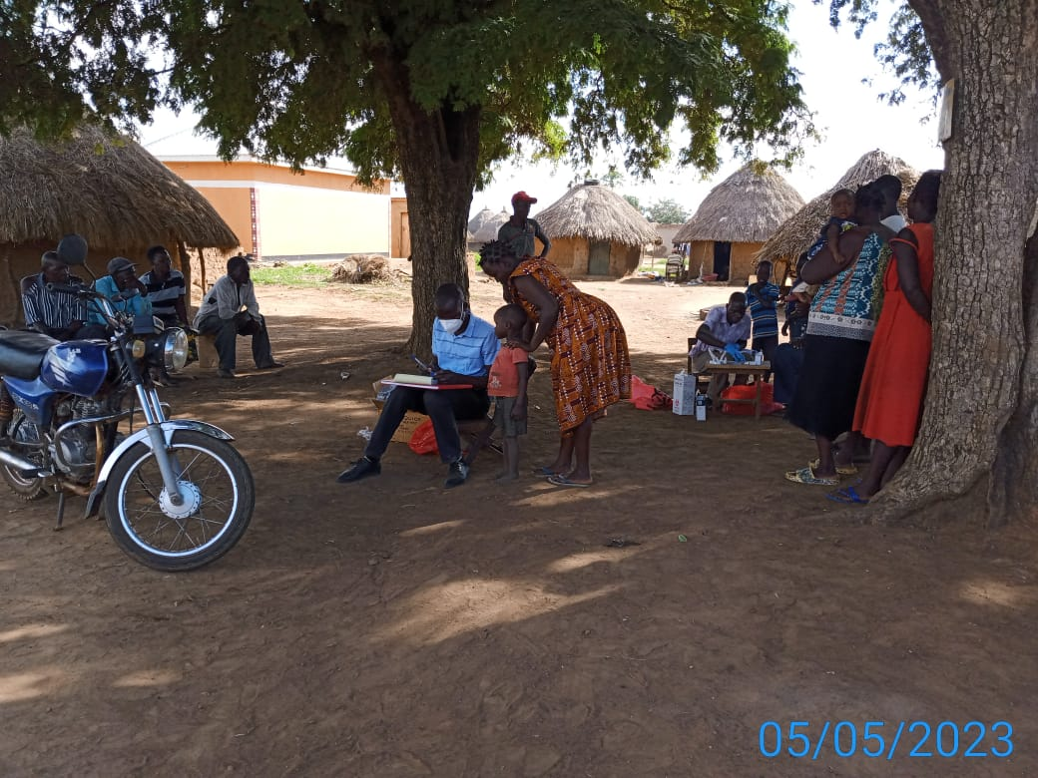
Community Drug Refill for HIV/TB and Home to Home HIV Testing.

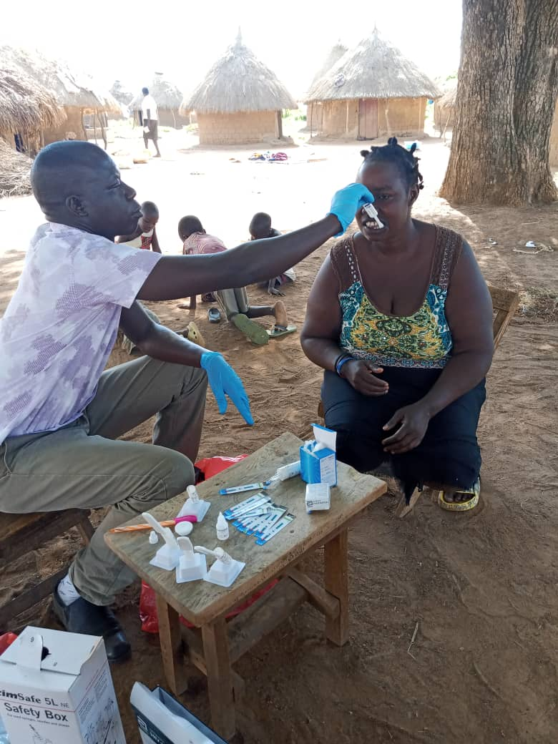
HIV Testing using Ora quick.

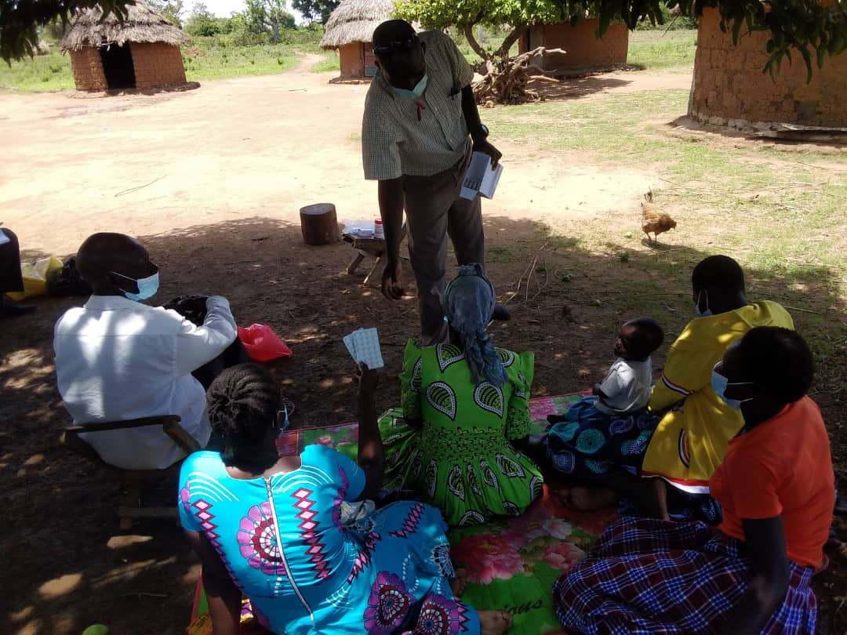
IPT community refill

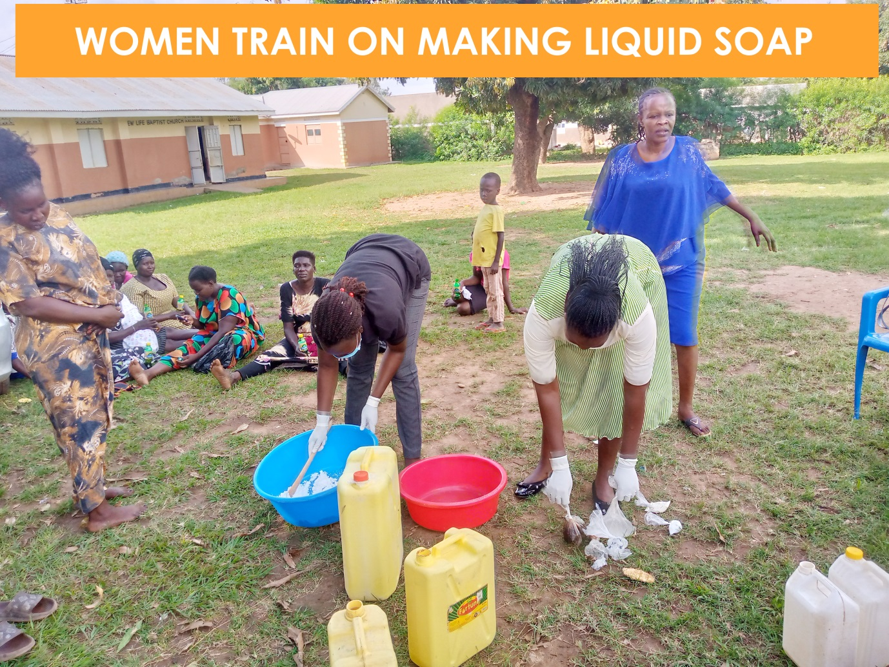

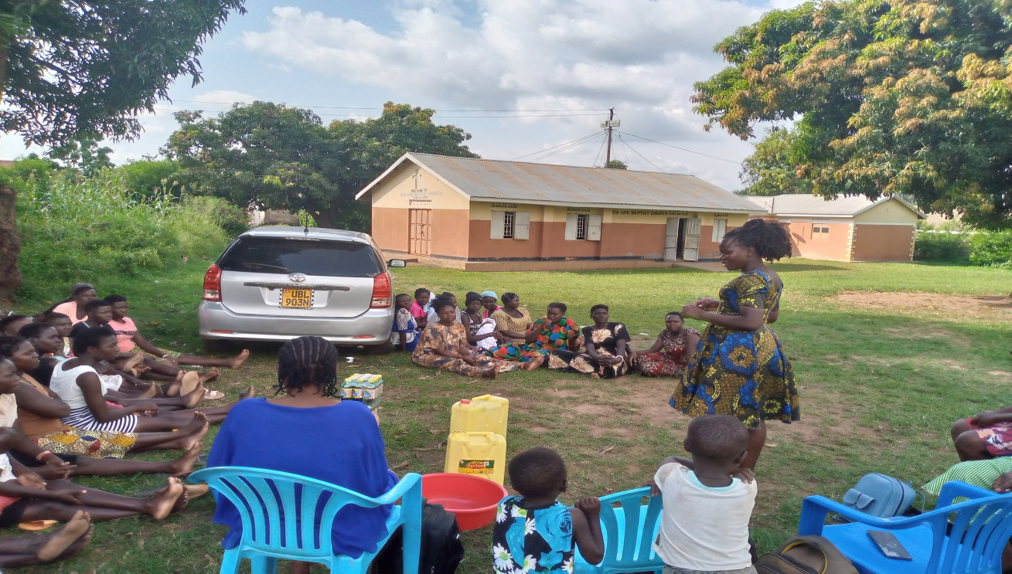
PLHIV Sensitization and awareness raising to promote postive living and behaviour change .
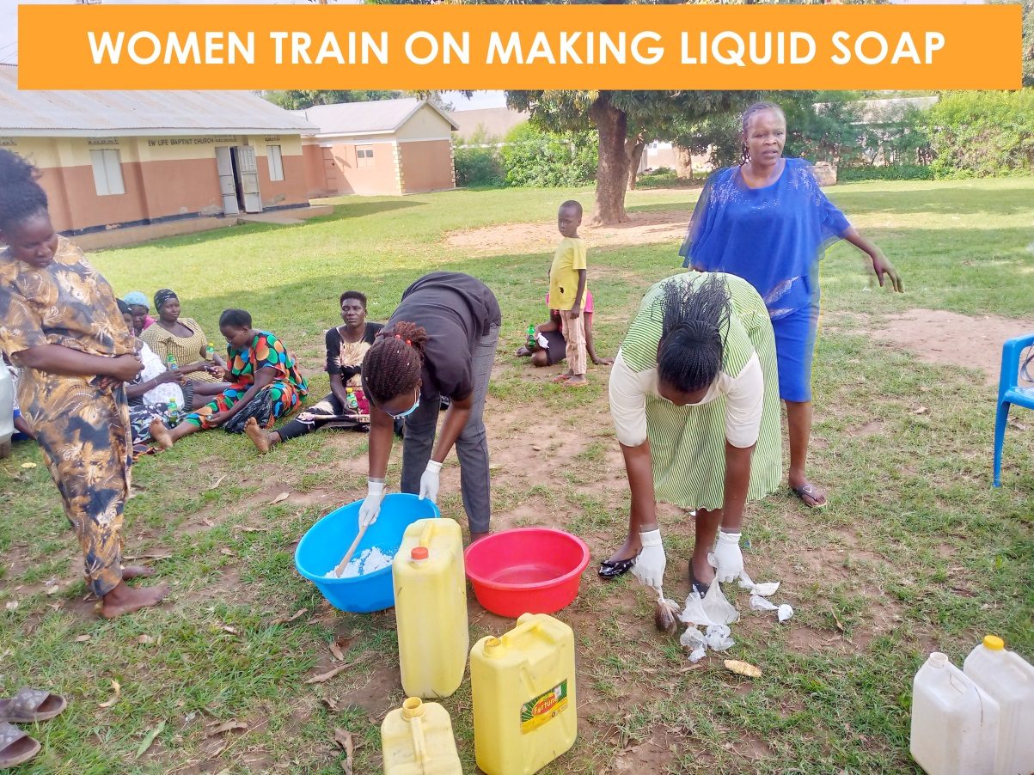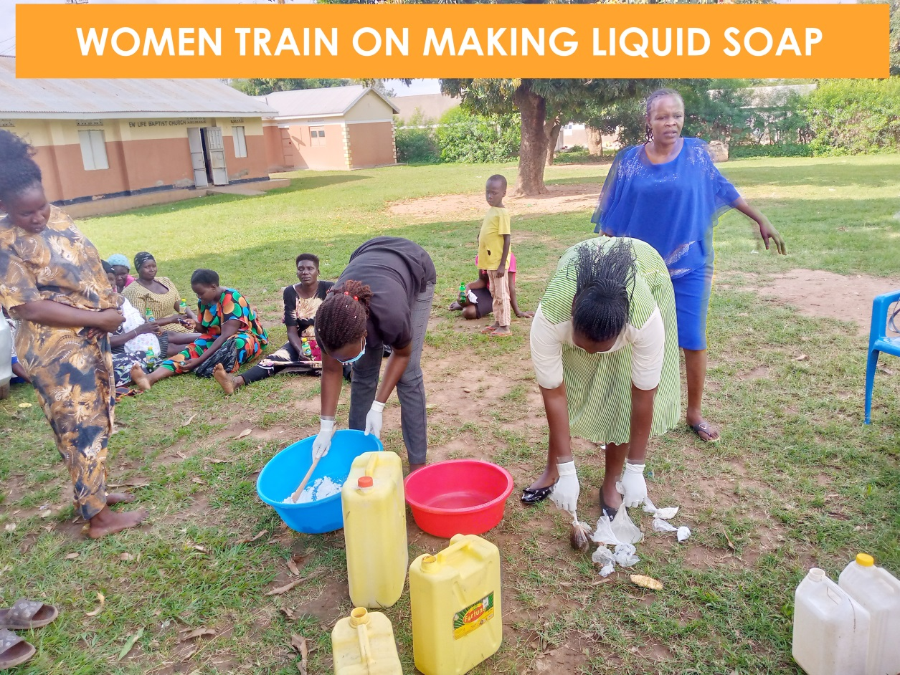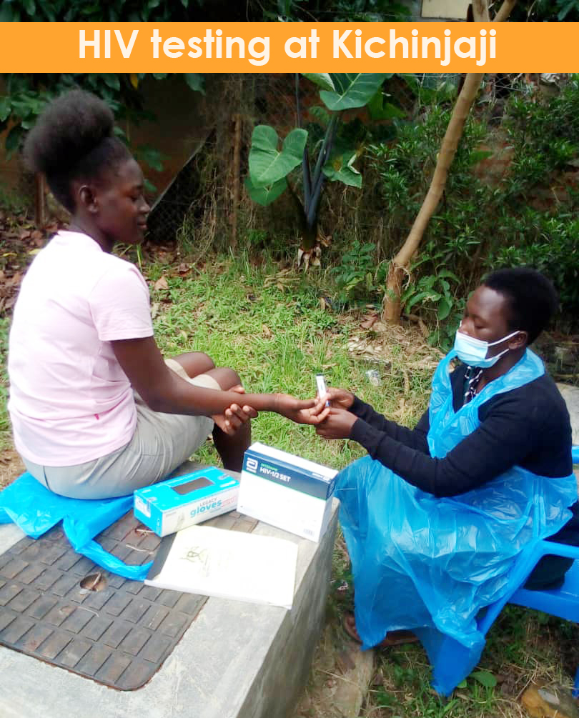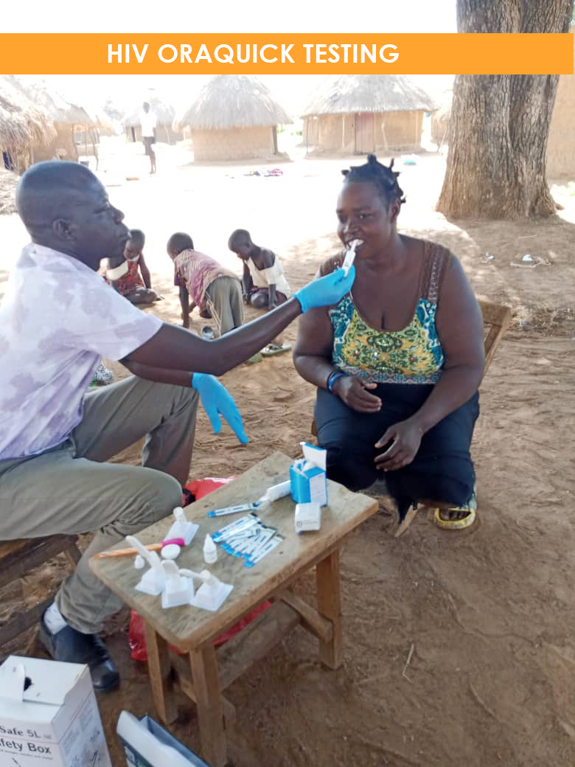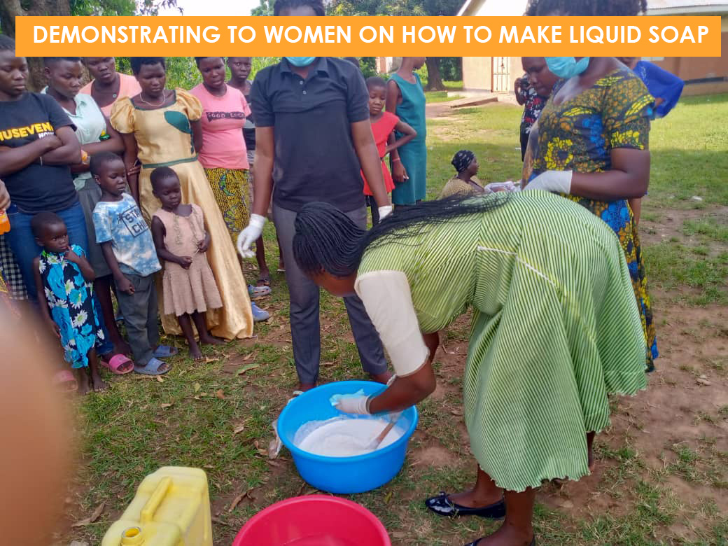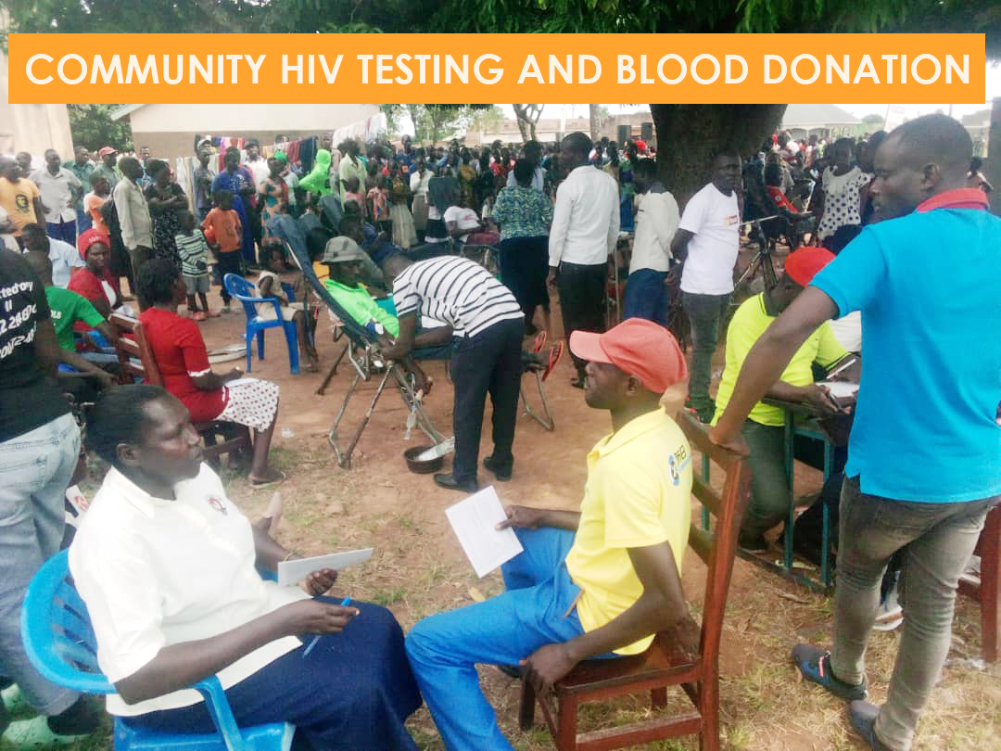

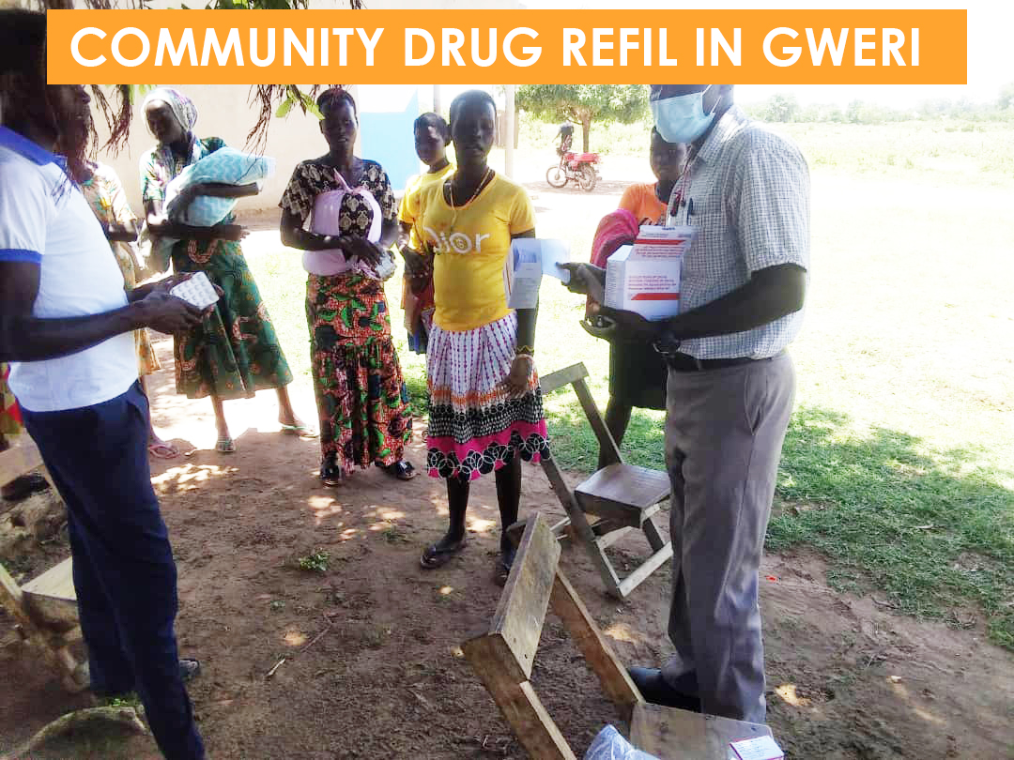

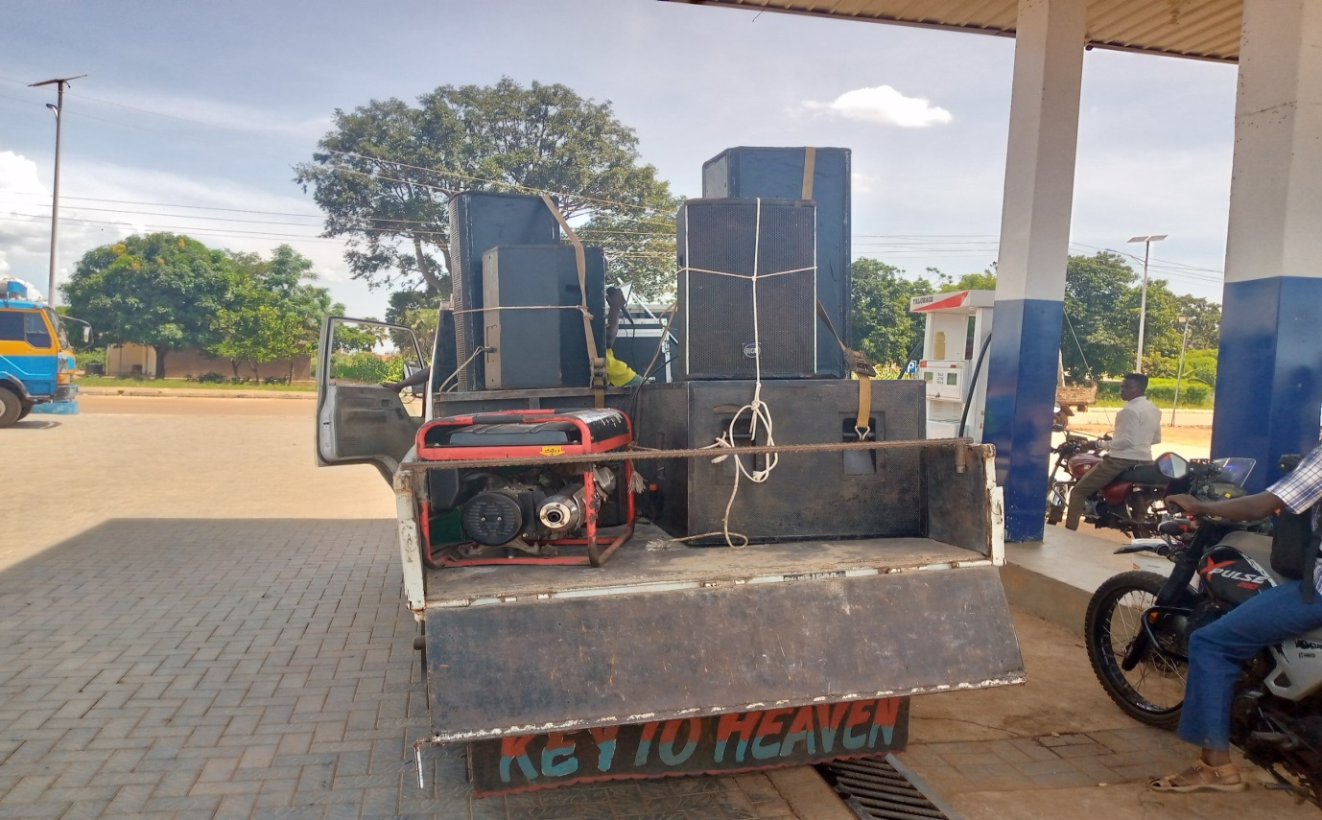
Demand Creation using Caravan car for Dissemination of HIV/TB& STIs Prevention information.

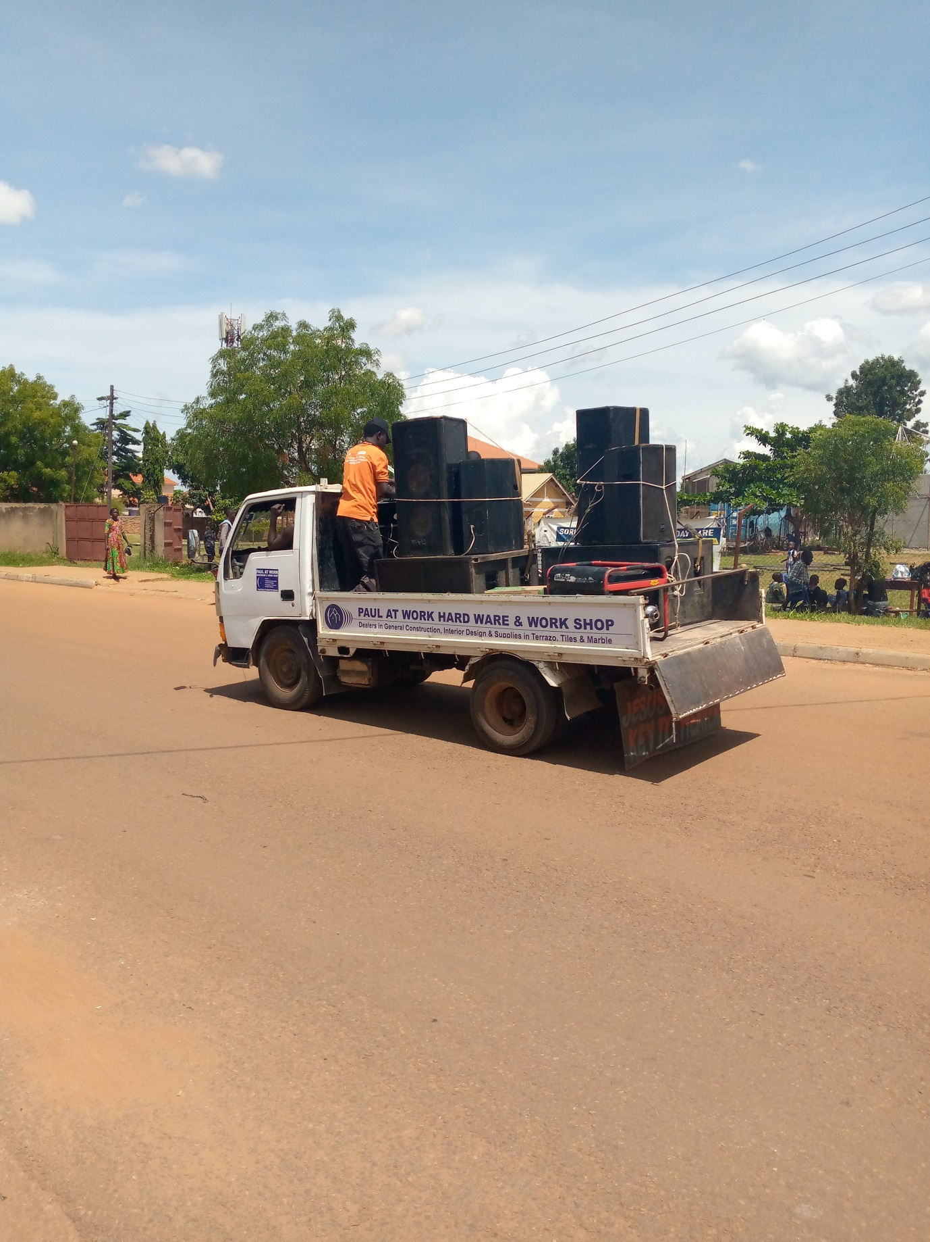
Demand Creation Awareness Creation for HIV/TB & STIs Prevention.
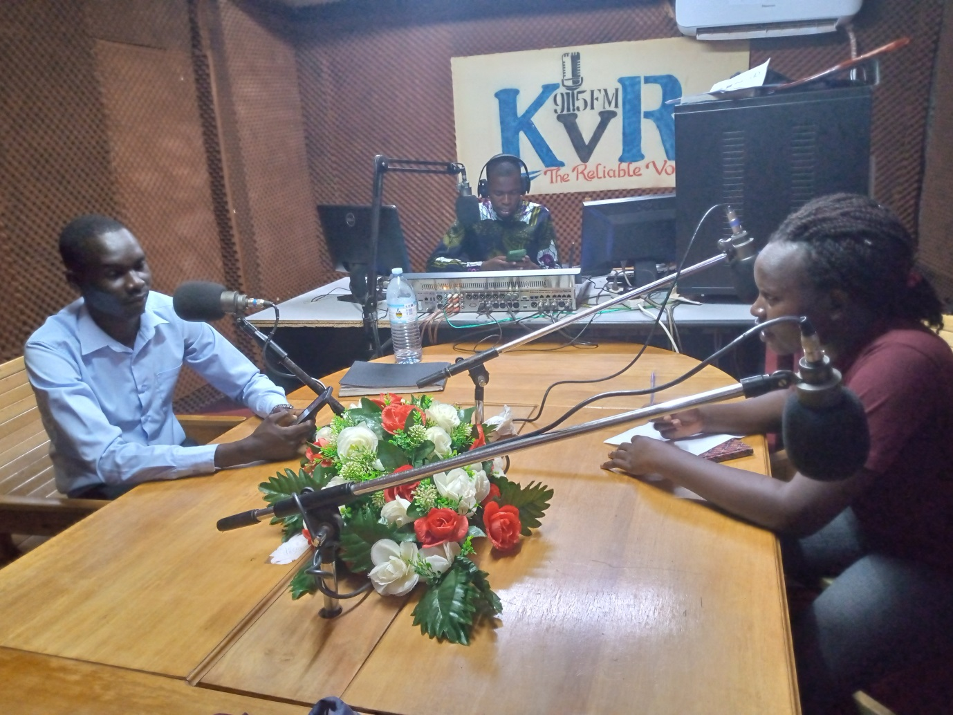
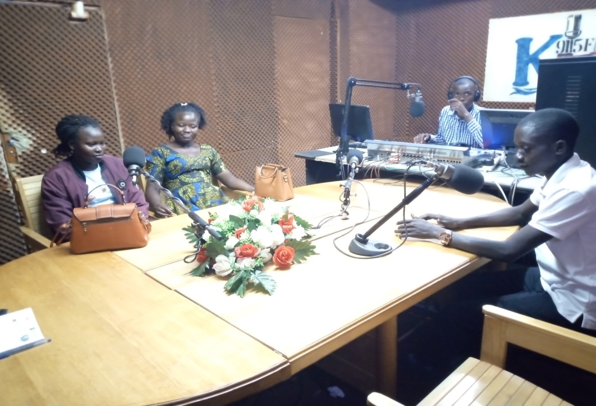
Kyoga Veritus Radio Talk show for Education Awareness about STIs, HIV&TB Prevention.

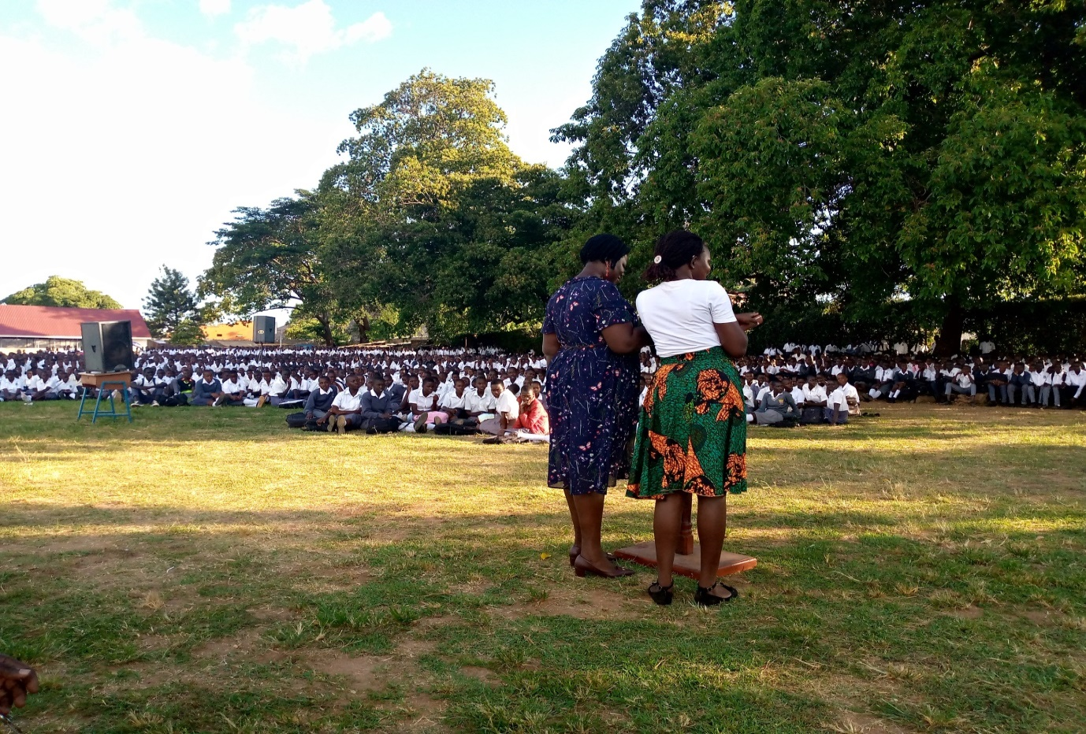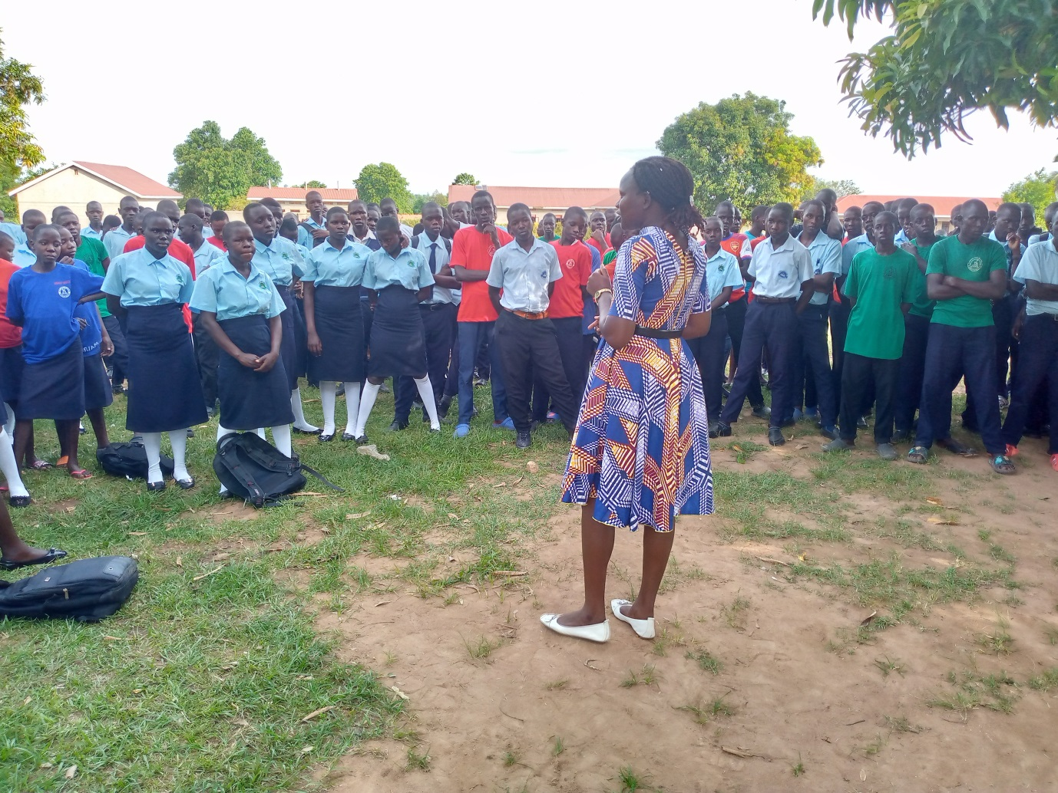Peer Educators conducting Health Education among Adolescent youth for the SRHR/HIV & STIs Prevention.
Linkage Facilitators receiving Bicycles for easing Follow up and Contact Tracing of Lost TB & HIV Clients

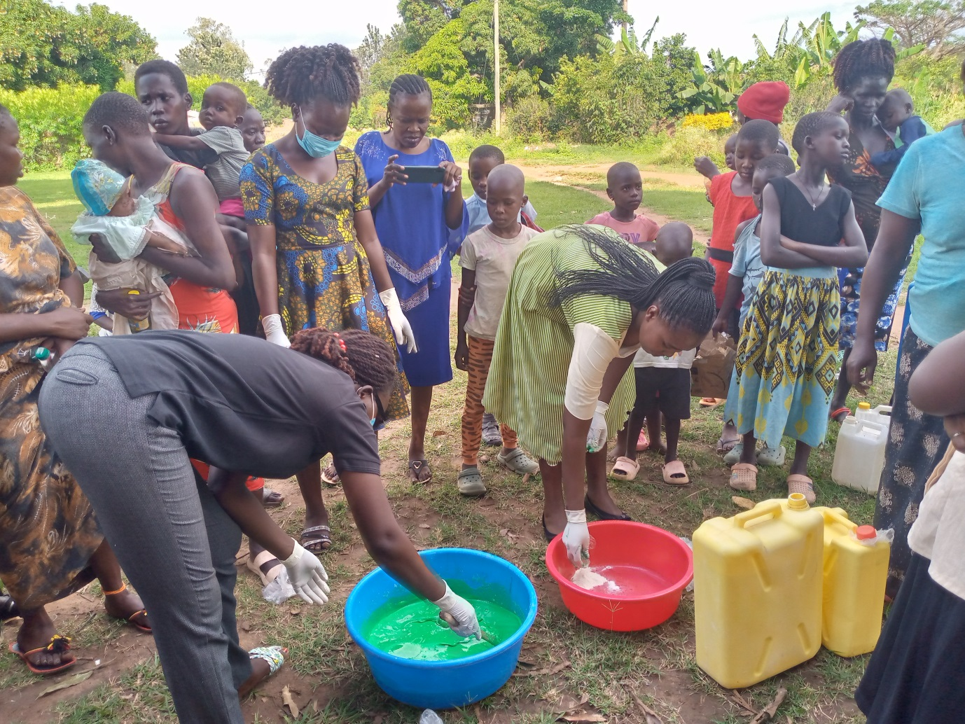
Liquid Soap Making rolled to households of KPPs

